Souls in Purgatory

edited by:
The Flame of Love of the
Immaculate Heart of Mary
-Canada-

Postal Station Jacques Cartier

P.O. Box 21111

Longueuil, Quebec

Canada J4J 5J4

Phone: 579-721-4027

www.theflameoflove.org
holymary@theflameoflove.org

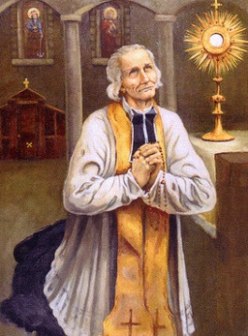
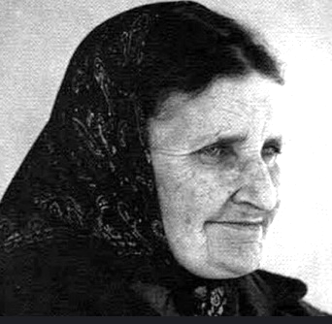
Souls in Purgatory

Many Christians have experienced extraordinary events with souls in Purgatory.
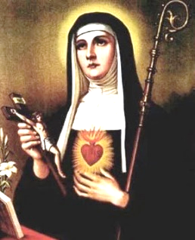
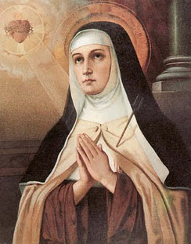
We can mention Maria Simma, known worldwide for the visits she received from these souls. She offered masses for the souls who visited her, but also fasts and sacrifices.

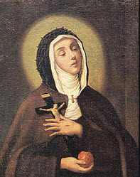
Likewise, there were many others, especially among the saints, who benefited from these visits, such as the Holy priest of Ars, Saint Gertrude, Saint Teresa of Avila, Saint Veronica and many others.

Free souls from Purgatory
by the Flame of Love
of the Immaculate Heart of Mary

The word "Purgatory" comes up several times in Elizabeth Kindelmann's Spiritual Diary. It is a sign that the Lord Jesus and the Blessed Virgin Mary absolutely want us to come to the aid of the souls in Purgatory. We can respond to their requests in several ways.

The following are some excerpts from the Spiritual Diary.

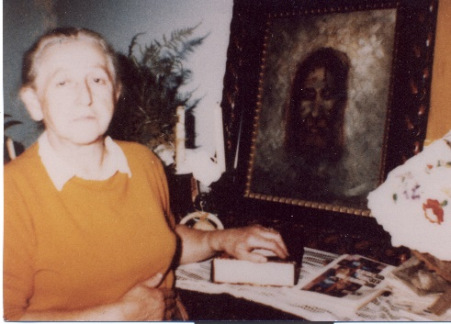
September 28, 1962

Jesus – "Since you are fulfilling this desire so great that I have for souls, my little one, do you know by what I will reward you? Thanks to the fast I have asked you to do, now, within eight days of death, the priest's soul will be freed from the fire of purgatory. And whoever has observed this fast will get this grace for a suffering soul. »

Lord Jesus - "Because of the observance of the fast that I ask, the souls of priests, on the eighth day after their death, will be delivered from purgatory."

October 4, 1962

Jesus – "My Heart will rejoice when you arrive; and the many souls you have helped to free yourself from purgatory through your sacrifices will greet you, all overflowing with joy. Like good friends, they can't wait to meet you. Get in with this boundless joy. And that nothing you have to do for my work of salvation seems tiring to you. Let our eyes blend into each other! In my eyes bathed in tears and blood, you will see my Heart's ardent desire for souls. Harvest with Me, my little one! I have grafted on your heart the desire of souls, and I will increase it constantly. But also take advantage of every opportunity! »

October 13, 1962

Elizabeth – I also asked for the outpouring of grace of the Flame of Love of the Blessed Virgin on the souls in pain, when the Lord Jesus allowed me to feel that at that moment a soul had just been liberated from purgatory. I felt in my soul an indescribable relief. At that moment, out of god's pure grace, my soul immersed itself in the immeasurable bliss of the soul that presented itself before God. Then I prayed with all the reverence of my soul for the dying priests. Meanwhile, a very distressing feeling flooded my entire interior. These are the sufferings that the Lord gives so that I may harvest souls with Him. During my deep recollection, a sigh of the Blessed Virgin, light as a breath, surprised my soul:

Virgin Mary – "Your compassion for the poor souls has so moved my maternal heart, my little one, that I grant you the grace you have asked for. If at any time, invoking my Flame of Love, you recite in my honour three Ave Maria, each time a soul will be freed from purgatory. During the month of the deceased (in November),at the recitation of each Ave Maria, ten souls will be freed from purgatory. Suffering souls must also feel the graceful effect of the Flame of Love of my mother's heart. »

August 31, 1963

Elizabeth – I attended the Holy Evening Mass. Then I stayed with Him for a long time. I begged him at length. The sacristine sister didn't realize it, and she left locked the door. We were both: God and I, with my prayer of supplication. Absorbed, I interceded in favor of the souls of purgatory. In my heart burned a great desire that many more be freed from the place of suffering. As I felt this great desire, the Blessed Virgin said to me:

Virgin Mary – "My little one, I reward the great desire and compassion you feel for the souls of purgatory. So far, you have recited three Ave Maria in my honour for the liberation of a soul. Now, to calm your ardent desire, ten souls will now be freed from the place of suffering. »

Elizabeth – I could hardly understand such great kindness. Instead of splitting me into four thanks, only a sigh came to my lips:
"Holy Mother of Mercy, thank you for so many graces!"

September 1, 1963, Monday

Elizabeth – Today is fasting day for priestly souls. As the Savior had asked me, by fasting with bread and water, I can free a priestly soul from purgatory. Fasting weakens me a little because I also do my housework in the usual way and I help my children.

September 24, 1963

Virgin Mary – "My Flame of Love, which I wish to spread upon you to an ever greater extent, also extends to the souls of purgatory. Be careful what I say, write my words and hand them over to the people concerned: in the families who observe the Holy Hour of family reparation on Thursdays or Fridays, if someone dies, after a single day of strict fasting observed by a family member, the deceased is released from purgatory. »

(Understand: if he died in a state of grace).
Note: Observing a "strict fast" does not mean that one should suffer from hunger; you have to eat bread and drink water.

May 18, 1964. Whit Monday

Elizabeth – I attended the Holy Mass. Before Holy Communion, the Lord Jesus said to me:
"As I see your firm determination to which you are faithful even on feast days, I have prepared a joy for you: today, from midnight, every hour a priestly soul suffering in purgatory will be freed."

Elizabeth – The Lord Jesus told me this because, at his request, I fast to bread and water every Monday, and I do not omit it even when a feast falls that day. I am glad to be able to keep fasting strict on this day, since He promised that after fasting on a Monday, a priestly soul would arrive in his divine presence. And He immediately flooded my soul with the suffering that these souls still endure, telling me that every hour a priestly soul will be freed, and that after a few hours they will be in his presence. This pain lasted barely a minute or two, but even on my knees, I almost collapsed because of the pain. After communing, the Lord Jesus allowed me to feel the liberation of a soul. He made my feelings vary from one extreme to the other: after the depths of suffering, He flooded me with the sublime joy of the soul reached in the presence of God. The state of my soul, trembling from the intoxication of graces, made me feel for hours freed from the force of gravity of the earth.

July 17, 1964
Elizabeth – My daughter-in-law asked me to get her some medications for her sick son. I had to wait more than an hour for the medicine… While waiting, a newspaper article caught my eye… I started to read a few lines when the Lord Jesus made a gentle request.

Jesus – “My little sunflower, help even more to free the suffering souls. I always share with you My eternal thoughts. Realize that even this short time is useful. If you put aside the newspaper article, you can help suffering souls come into My presence. This sharing in My work of Redemption is filled with merits. You see how I simplify what I ask of all of you. Everyone can fulfill My eternal thoughts. Write them down! As you communicate My words to others, many souls will benefit.”

November 1 - 2, 1965

Jesus – "God smiles at you. You see, by my divine smile, you can more easily bear the great and violent sufferings of which the souls of purgatory have a great need, because now you have taken part in the work on behalf of the suffering Church. Suffer with a smile! Let no one know, that no one sees, that this remains our secret to the two of us! Only God can concede this, and I only give it to those souls who know how to bear with a smile the incessant sacrifices. »

August 15, 1980

The Lord Jesus and the Blessed Virgin spoke to me alternately. The words of the Blessed Virgin resonated with a firm but benevolent energy in my heart. She asked the clergy, the people consecrated to God (religious, religious), and the Christian faithful around the world to fast on Mondays with bread and water when they have the opportunity to do so.

Jesus – "The Church and the whole world are in grave danger, and you, by your strength, cannot change the situation. Only the Most Holy Trinity can help you, through the concerted intercession of the Most Holy Virgin, of all angels and saints, and of the souls liberated with your help."

Virgin Mary – "The priests who observe the fast on Monday, at each of the holy Masses they will celebrate that week, will release at the time of the Consecration countless souls from purgatory.
The people consecrated to God and the lay people who keep the Monday fast will release during that week, whenever they commune and when receiving the Sacred Body of the Lord, a host of souls of purgatory. »

Elizabeth later asked, "What does it mean to be countless? A thousand, a million souls? »

Jesus – "More!"

Publications
of the Flame of Love Movement
in Canada
We are proud to present them to you to accompany your steps towards the expansion of the Flame of Love of the Virgin Mary in all the hearts.
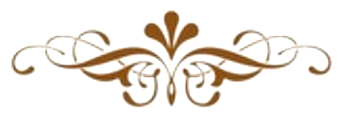
Thank you very much to anyone who takes the time to read these documents. Hopefully they will shed more light on understanding the messages given to Elizabeth by the Lord Jesus and the Virgin Mary.

. Conference of Father Gabriel Róna
. Declaration of his Eminence Cardinal Péter ERDÓ
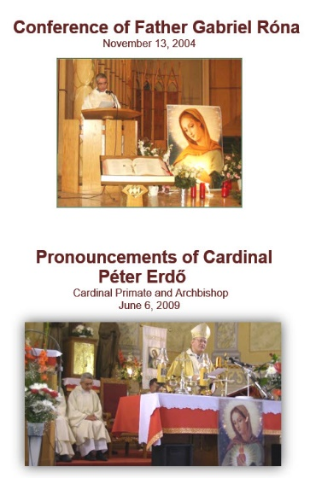
This conference was given by Father Gabriel Róna on November 13, 2004, in Montreal, during the 3rd national congress.
Father Gabriel makes an important link with the Fatima apparitions: the triumph of the Immaculate Heart of Mary announced at Fatima takes place through this great grace of the Flame of Love!
In the same document, we offer you the statement of His Eminence Cardinal Péter ERDŐ, Primate of Hungary and Archbishop of Esztergom-Budapest, regarding the Association "Movement Flame of Love of the Immaculate Heart of Mary".
This 22-page booklet is available in English and French.

History of the Flame of Love Movement

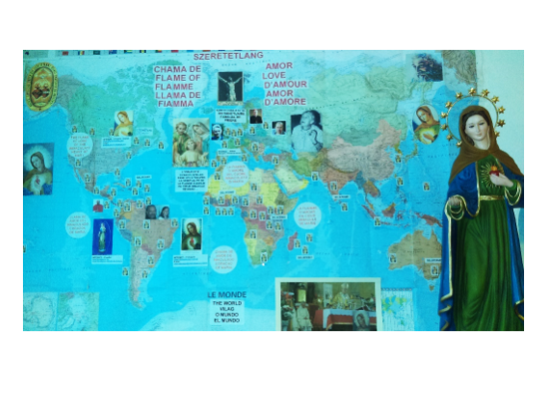
This booklet presents the history of the Flame of Love Movement from its beginnings with Elizabeth Kindelmann, in Hungary.

It is very useful to learn about the different countries where the Flame of Love Movement has spread.

The 36-page booklet is also available in French and Spanish.

Cenacles Prayers booklet

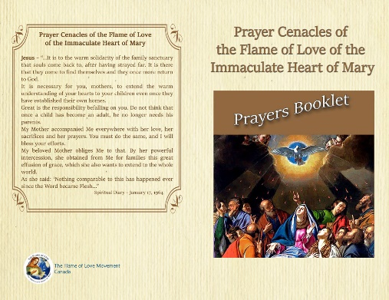
This 42-page prayer booklet is available in color.

It is important that prayer groups can have this booklet, whether for online prayer cenacles, at church or at home.

You will also find the meditations of the Rosary of the Flame of Love at the end of the booklet.

Available only in English for the time being.

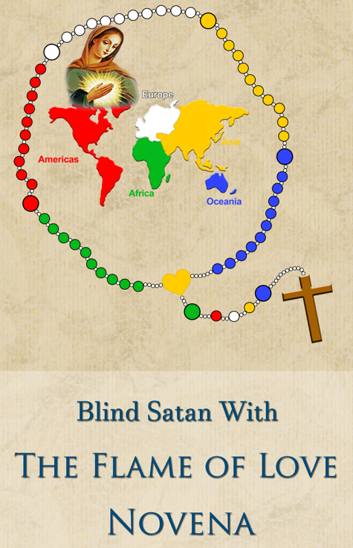
Blinding Satan with
the Flame of Love Novena

The Novena booklet has been much appreciated since we began to distribute it.

The Mysteries of the Rosary are at the end of this 36-page booklet.

Also available in French, (40p.) English and Spanish

LOVING WHILE BEING LOVED
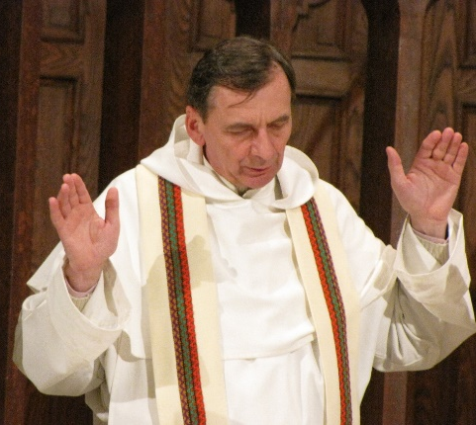
LEARNING TO LOVE
from the Flame of Love Spiritual Diary

Fr Domonkos Mészáros, op

Part I & II - 75 pages

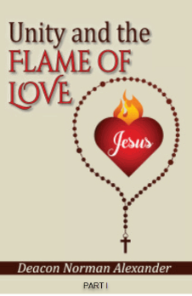
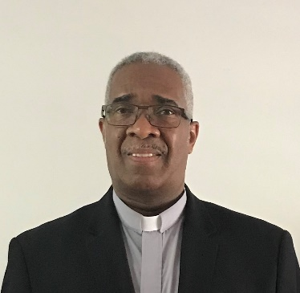

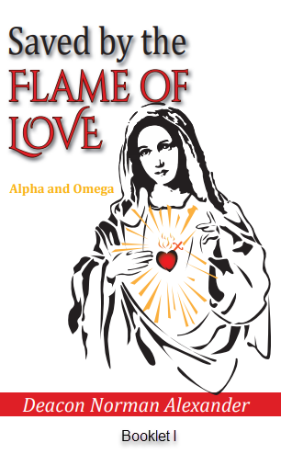
DEACON NORMAN ALEXANDER of the Diocese of Memphis in Tennessee has endeavored to write about the wonderful gift of the Flame of Love of the Immaculate Heart of Mary. Saved by the Flame of Love, follows Unity and the Flame of Love published February of 2019. He is committed to promoting the Flame of Love because there has never been a time of grace like this since the Word became flesh. These are the words of Jesus and Mary, and we know them to be trustworthy.

Unity and the FLAME OF LOVE
2 Booklets / Part I & Part II
54 pages
Saved by the FLAME OF LOVE
2 Booklets / Part I & Part II
63 pages

by
Deacon Norman Alexander

